**Project 2 Interactive Quiz App Documentation**

For this project, there was little that I already knew on how to program in JavaScript, HTML or CSS. I had a general idea on how to create the visual interface and include some if/else statements for the score messages and a 00:00:00 timer. I had to research on how to code dragging and dropping in HTML and JavaScript, how to create a button that toggles between states, how an undo button works, and so on.

If there was any part of the assignment that I felt was easy, it was that the scaffolding files that were provided to the class. It was also easy to test the app after every small change made to the HTML, JavaScript and CSS codes by checking the console for any error messages. I would be able to spot any strange behavior on the screen, so most of the time the debugger was not used. There were no issues using my XAMPP server. Still, because I have not created a quiz app before using JavaScript, most of the assignment felt like a real challenge. I had to frequently test my code and figure out how to integrate different objectives. Progress was slow as I found different sources of code online that were inconsistent when compared to each other such as how to create a stopwatch.

After being provided the scaffolding files, I went through the app.css file to make size and color modifications in order to learn about to distinguish all the different CSS classes. Then, I searched for examples of code online regarding dragging and dropping so I may integrate the code into my project. The code I found also allowed me to calculate the number of ‘correct answers’. Afterwards, I focused on testing buttons that respond to click events, eventually creating a multistate button that starts a timer, stops it, and displays a score message. With all the code I had at hand, I had to modify whatever I could to meet the main objectives. I spent the most time making changes to my HTML page: DnDQuiz.html and functions.js. I decided not to create multiple versions of the project. Similar lines of code in the HTML and functions.js file allowed me to do testing with the termsContainer and definitionsContainer. Otherwise, I would comment out, remove, or copy and set aside any large chunks of code that I was testing or no longer needed.

While I made progress and better understood the code from frequent testing and modifications, I fell short of the main objectives. The Play button in my app starts a timer than display time correctly in hh:mm:ss format until the counter reaches 600. Yet, the user does not have to click the Play button to start dragging and dropping. The drag and drop code that I found to be useful does not allow the user to drag the terms into the wrong spaces. I spent time trying to reduce the amount of drag and drop functions and renaming them. However, I could not figure out how to enable dragging and dropping the terms onto ‘incorrect answer’ spaces without receiving error messages in the console. Due to limited time, using a JSON file for terms and definitions and implementing the Undo button were objectives I did not meet.

Although I have used the Java language in the past for projects, I have had almost no experience in using JavaScript. With more experience over time, I should be able to implement and integrate more functions together to create a more robust application.

Resource used for drag and drop code: <https://www.ikhtabirni.com/how-to-make-a-drag-and-drop-game.html>

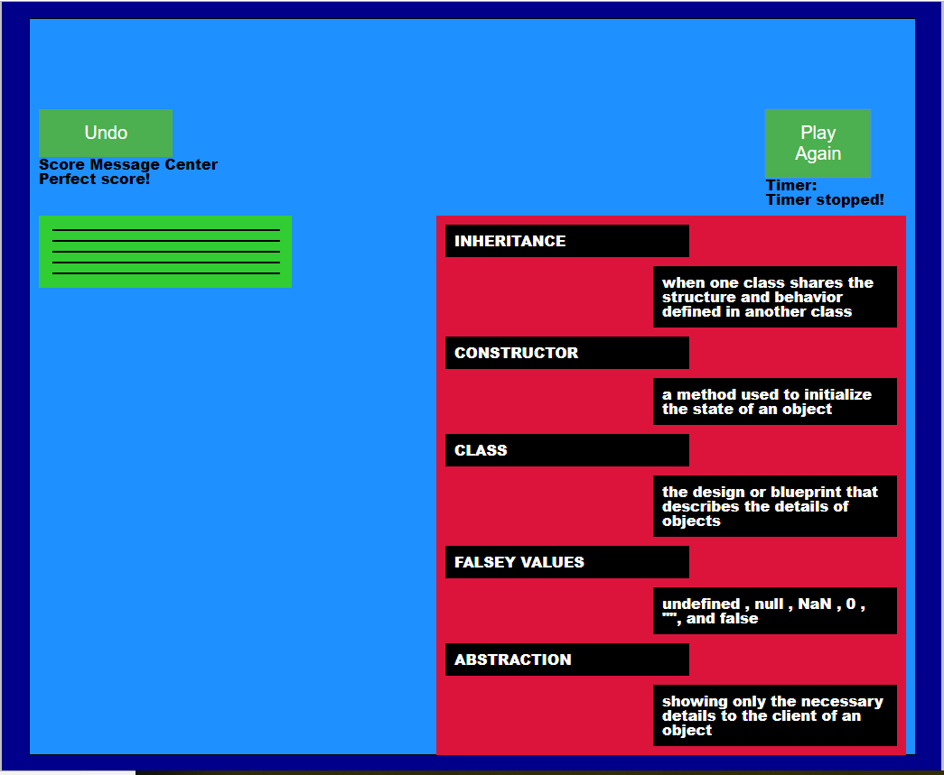

HTML files:

* DnDQuiz.html

Css files:

* app.css
* reset.css

JS files:

* app.js
* framework.js
* functions.js